SQL SCRIPT FOR COFFEE SHOP SALE
Data cleaning
UPDATE [Coffee Shop Sales]
SET transaction_date = CONVERT(date, transaction_date, 105);

ALTER TABLE [Coffee Shop Sales]
ALTER COLUMN transaction_date DATE;

UPDATE [Coffee Shop Sales]
SET transaction_time = CONVERT(time, transaction_time);

ALTER TABLE [Coffee Shop Sales]
ALTER COLUMN transaction_time TIME;
TOTAL SALES
SELECT
ROUND(SUM(unit_price * transaction_qty), 0) AS Total_Sales
FROM [Coffee Shop Sales]
WHERE transaction_date >= '2023-05-01'
AND transaction_date < '2023-06-01';
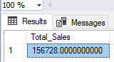
TOTAL SALES KPI - MOM DIFFERENCE AND MOM GROWTH
WITH monthly_sales AS (
SELECT
YEAR(transaction_date) AS year,
MONTH(transaction_date) AS month,
SUM(unit_price * transaction_qty) AS total_sales
FROM [Coffee Shop Sales]
WHERE transaction_date >= '2023-04-01'
AND transaction_date < '2023-06-01'
GROUP BY YEAR(transaction_date), MONTH(transaction_date)
)
SELECT
year,
month,
ROUND(total_sales, 0) AS total_sales,
ROUND(
(total_sales - LAG(total_sales) OVER (PARTITION BY year ORDER BY month))
/ LAG(total_sales) OVER (PARTITION BY year ORDER BY month) * 100,
2
) AS mom_growth_pct
FROM monthly_sales
ORDER BY month;
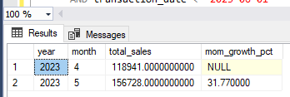
TOTAL ORDERS by MONTHS
SELECT
YEAR(transaction_date) AS year,
MONTH(transaction_date) AS month,
COUNT(*) AS total_orders
FROM [Coffee Shop Sales]
GROUP BY YEAR(transaction_date), MONTH(transaction_date)
ORDER BY year, month;

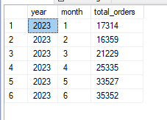

CALENDAR TABLE – DAILY SALES, QUANTITY and TOTAL ORDERS
SELECT
transaction_date,
ROUND(SUM(unit_price * transaction_qty), 0) AS total_sales,
SUM(transaction_qty) AS total_quantity_sold,
COUNT(*) AS total_orders
FROM [Coffee Shop Sales]
WHERE transaction_date = '2023-05-18'
GROUP BY transaction_date;
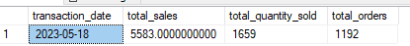
SALE TREND PERIOD
SELECT
YEAR(transaction_date) AS year,
MONTH(transaction_date) AS month,
ROUND(SUM(unit_price * transaction_qty), 0) AS monthly_sales
FROM [Coffee Shop Sales]
GROUP BY YEAR(transaction_date), MONTH(transaction_date)
ORDER BY year, month;
WITH monthly_sales AS (
—

SELECT
YEAR(transaction_date) AS year,
MONTH(transaction_date) AS month,
SUM(unit_price * transaction_qty) AS total_sales
FROM [Coffee Shop Sales]
GROUP BY YEAR(transaction_date), MONTH(transaction_date)
)
SELECT
year,
month,
ROUND(total_sales, 0) AS total_sales,
ROUND(
(total_sales - LAG(total_sales) OVER (PARTITION BY year ORDER BY month))
* 100.0
/ NULLIF(LAG(total_sales) OVER (PARTITION BY year ORDER BY month), 0),
2
) AS mom_growth_pct
FROM monthly_sales
ORDER BY year, month;
